**Full Stack Development with MERN**

**Frontend Development Report**

|  |  |
| --- | --- |
| Date | 20th July,2024 |
| Team ID | SWTID1720026558 |
| Project Name | Book a doctor |
| Maximum Marks |  |

**Project Title: Book a Doctor App**

Date: 20 July, 2024

Prepared by: Aadya Nair, Naveen George Joseph, Snigdha, Mihir Rana

**Objective**

The objective of this report is to document the frontend development progress and key aspects of the user interface implementation for the Book a Doctor project. This report aims to provide a comprehensive overview of the various components, functionalities, and design choices made during the development process, ensuring a clear understanding of the current state and future direction of the project. Key focus areas include the integration of user-friendly features, responsive design, and the implementation of a seamless user experience for finding and booking appointments with doctors.

**Technologies Used**

* **Frontend Framework:** React.js
* **State Management:** [Redux/Context API, if applicable]
* **UI Framework/Libraries:** [e.g., Material-UI, Bootstrap]
* **API Libraries:** [e.g., Axios]

**Project Structure**

Give Screenshot of Frontend Project with explanation

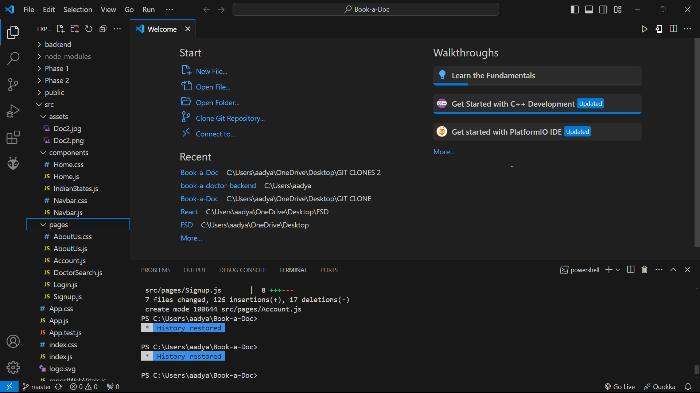

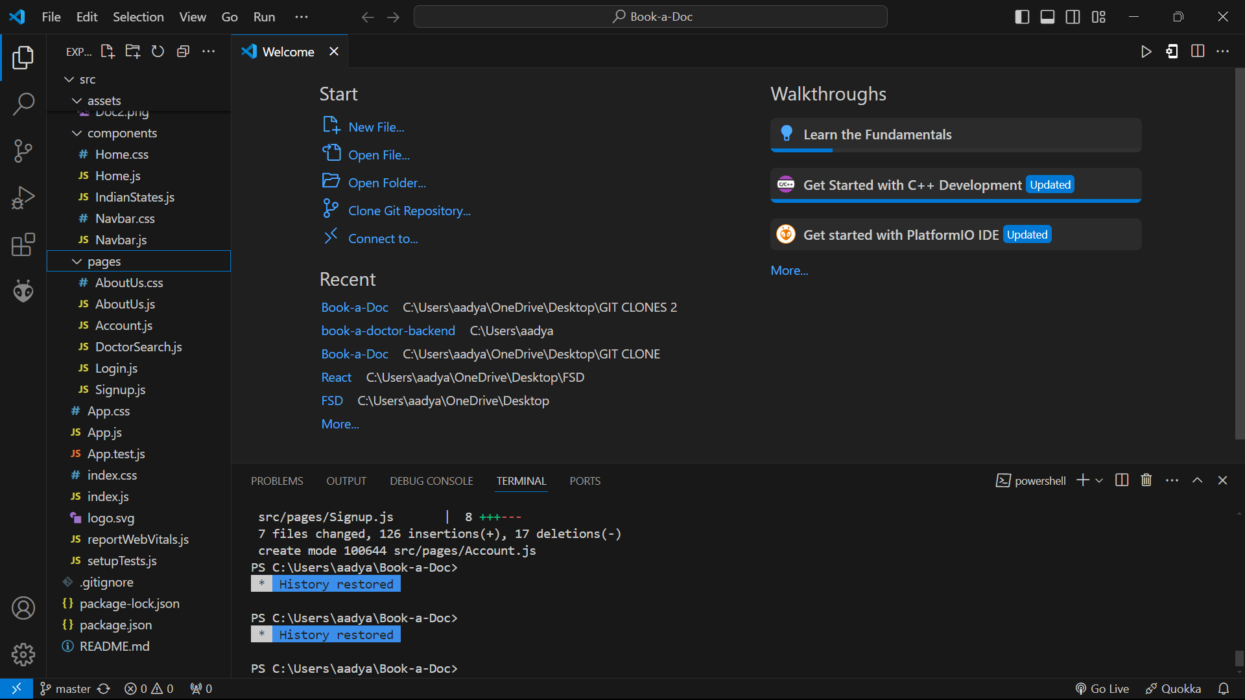

**EXPLANATION**

This gives an overall view of the project structure, including the configuration and setup files necessary for the project.

**src Directory**

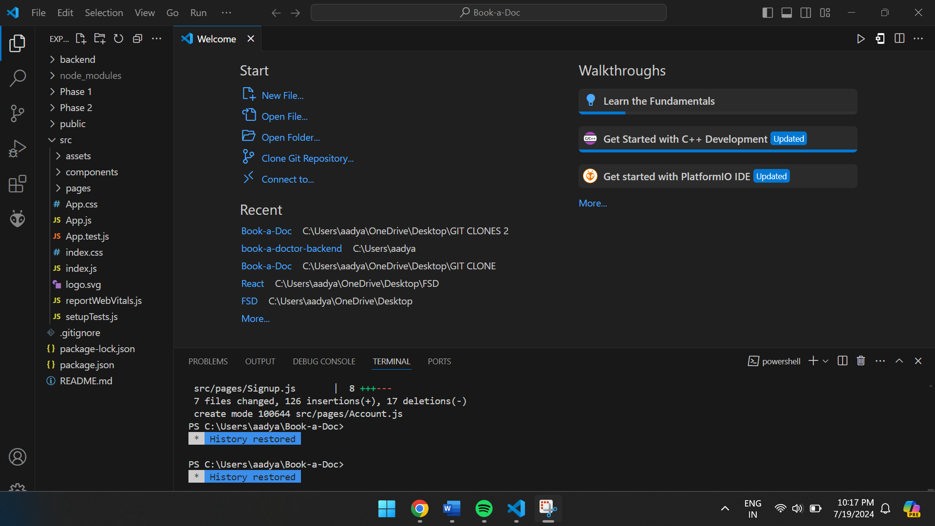

**EXPLANATION**

This directory holds the core application code, including components, pages, and other assets.

**Src/components Directory**

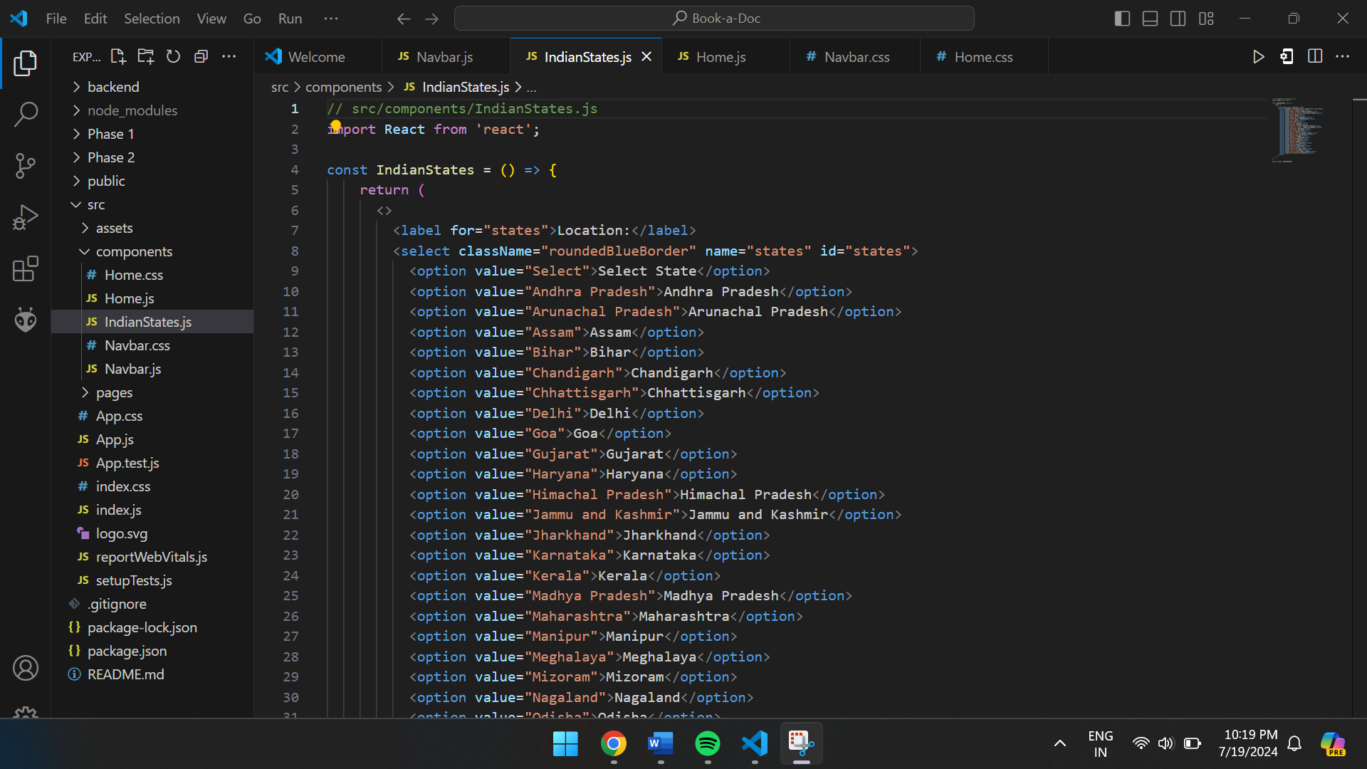

**Explanation:**

This folder contains reusable UI components that form the building blocks of the application.

**src/pages Directory**

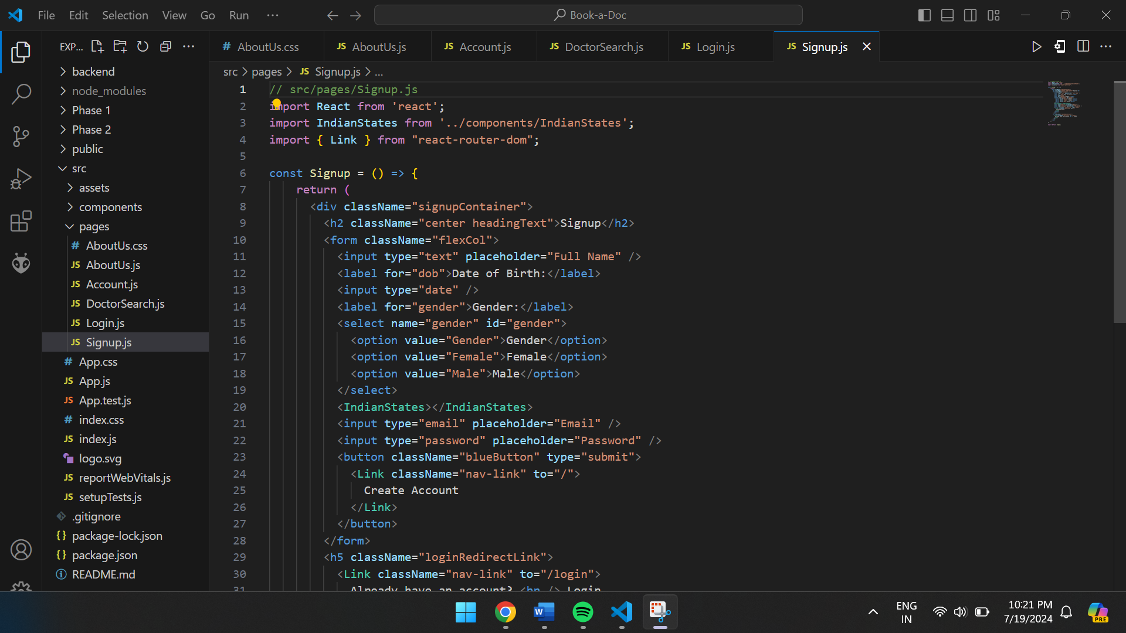

**Explanation:**

This directory organizes the main pages of the application, each representing a different route.

**src/assests Directory:**

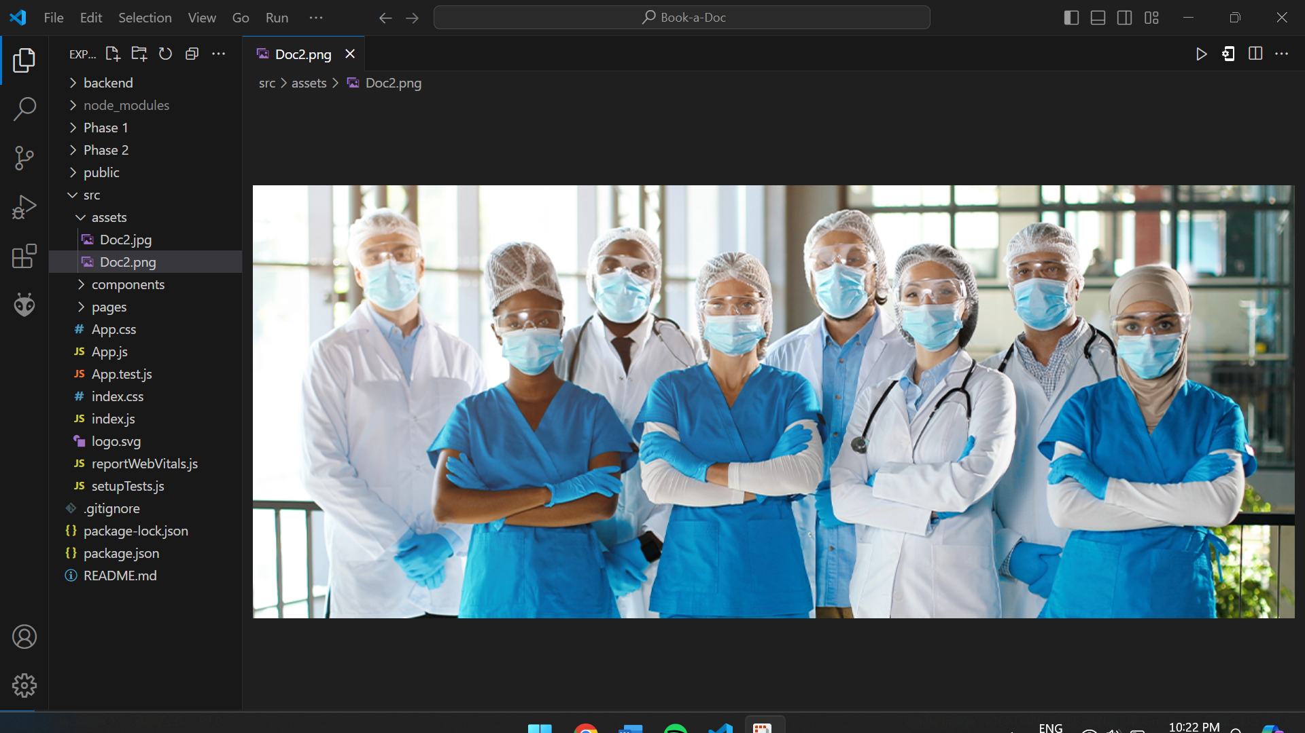

This folder holds static resources like images and CSS files that are used throughout the application.

**src/App.js:**

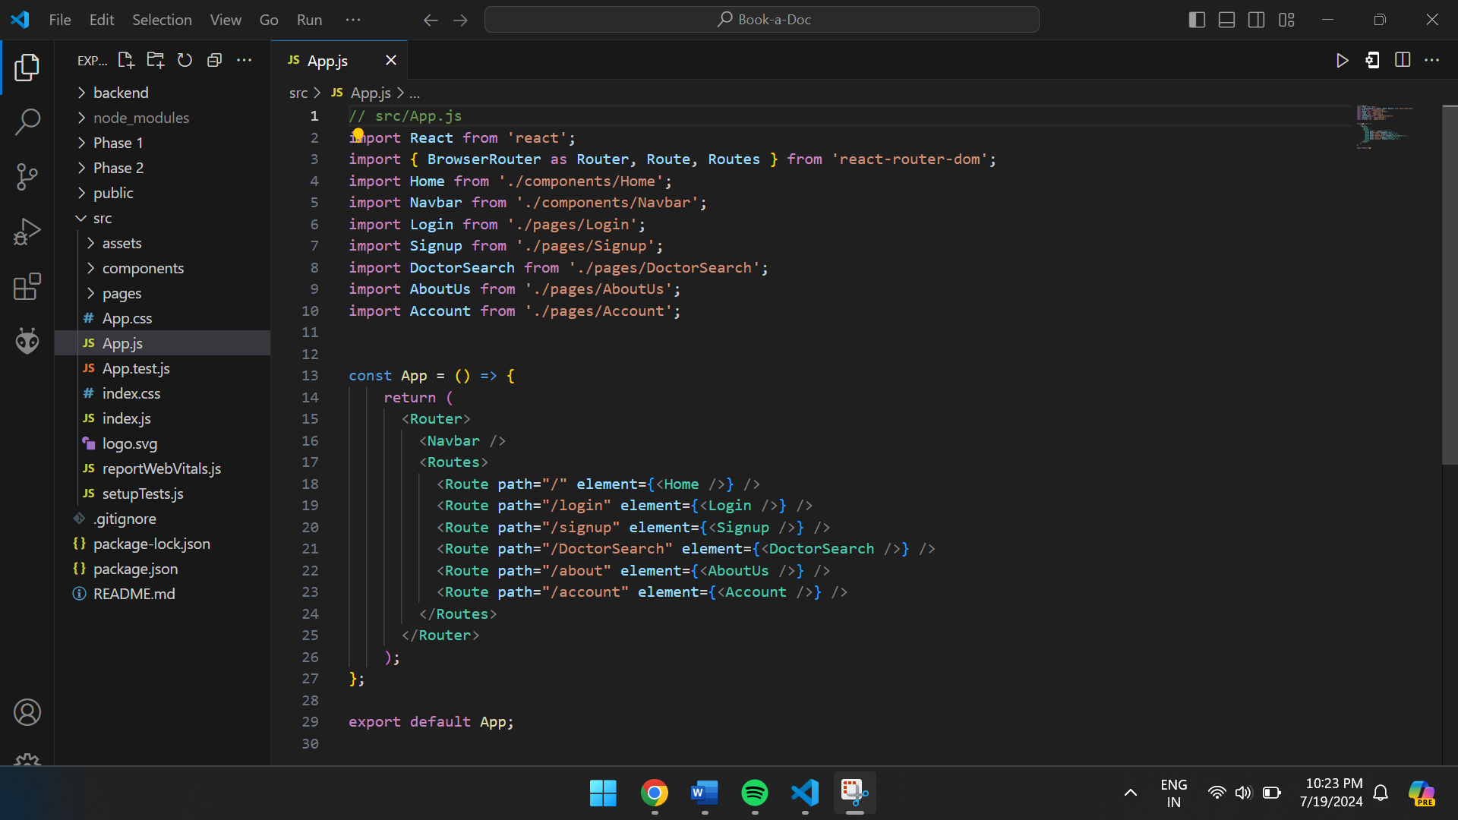

**Explanation:**

This file is the entry point for the React application and sets up the main structure and routing.

**src/Index.js:**

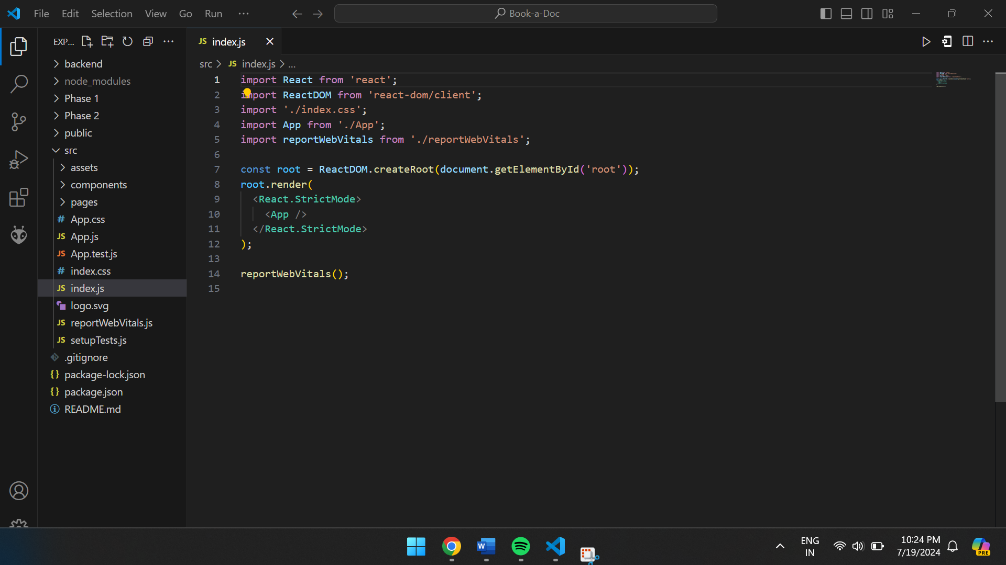

**Explanation:**

This file bootstraps the React application and attaches it to the HTML document.

**public Directory:**

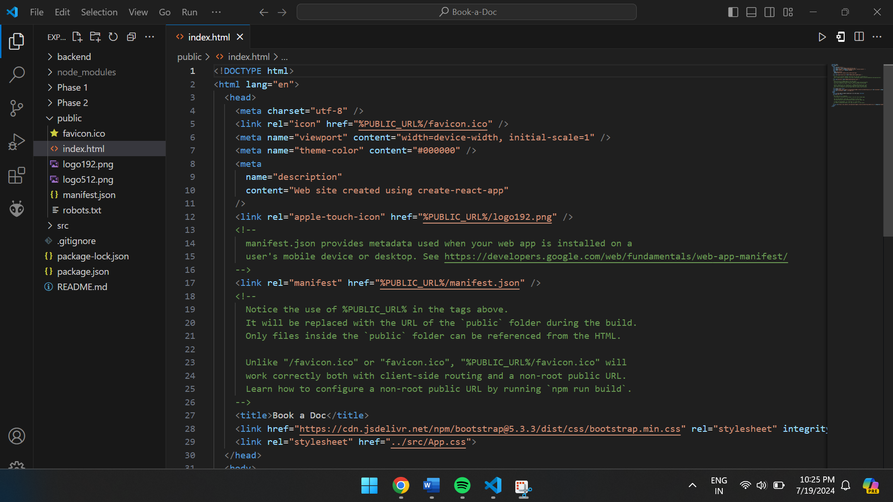

**Explanation:**

This folder contains the static HTML file and other assets that the application relies on during runtime.

**Routing**

Routing is managed using React Router. Here are the main routes:

* **/home** - Landing page of the application.
* **/dashboard** - Dashboard displaying user data and statistics.
* **/profile** - User profile management.

**User Interface (UI) Design**

**Design Principles:**

* **Consistency: Uniform styling across all pages.**
* **Simplicity: Clean and intuitive interface.**
* **Accessibility: Adheres to accessibility standards.**
* **Responsiveness: Optimized for all devices.**

**Implementation**

* **React.js: For building reusable components.**
* **Material-UI: For pre-designed components based on Material Design.**